

Dissertation
KF7029
MSc Computer Science
and Digital Technologies Project
Student Name: VENKATA SREEHARSHA ASAM

Student ID: 21027847

Supervisor Name: FARAH AHMED

Second Supervisor Name: NAUMAN ASLAM

MSc Programme: DATA SCIENCE WITH ADVANCED PRACTICE
Dissertation Title: EFFECTIVE USAGE OF IOT SENSORS ON STADIUMS FOR PREDICTING AND MONITORING THE SOIL MOISTURE LEVELS USING AI

Month and Year of Submission: 05/2024

Academic Publication Venue: IEEE TRANSACTIONS ON MACHINE LEARNING IN COMMUNICATIONS AND NETWORKING

Declaration
I declare the following:
- that the material contained in this dissertation is the result of my own work and that due acknowledgement has been given in the bibliography and references to ALL sources be they printed, electronic or personal.
- I have not use the services of any agency providing model or ghost-written work, nor have I employed unauthorised artificial intelligence in the preparation of this dissertation.
- the Word Count of this Dissertation is 7900
- that unless this dissertation has been confirmed as confidential, I agree to sections of the dissertation being placed on the eLearning Portal (Blackboard), if deemed appropriate, to allow future students the opportunity to see examples of past dissertations. I understand that if displayed on the eLearning Portal it would be made available for no longer than five years and that students would be able to print off copies or download.
- I agree to my dissertation being submitted to a plagiarism detection service, where it will be stored in a database and compared against work submitted from this or any other Department or from other institutions using the service.
In the event of the service detecting a high degree of similarity between content within the service this will be reported back to my supervisor and second supervisor, who may decide to undertake further investigation that may ultimately lead to disciplinary actions, should instances of plagiarism be detected.
- I have read the Northumbria University Policy Statement on Ethics in Research and I confirm that ethical issues have been considered, evaluated, and appropriately addressed in this research.

SIGNED: VENKATA SREEHARSHA ASAM
DATE: 20-05-2024
Effective Usage of IoT Sensors on Stadiums for Monitoring & Predicting the Moisture Level Using AI
Venkata Sreeharsha Asam
Northumbria University, Newcastle upon Tyne, NE1 8ST UK
Corresponding author: V. ASAM (venkata.asam@northumbria.ac.uk)

ABSTRACT Cricket is a highly popular worldwide sport. It is necessary to maintain a well-organised water distribution system to ensure smooth gameplay with no interruption. Water scarcity has been a serious problem in many countries over the past few years. Controlled usage helps in saving water without compromising the cricket pitch condition. This project aims to predict the soil moisture levels of cricket ground with integration of IoT (Internet of Things) with AI (Artificial Intelligence) to help optimal usage of water. A Hardware prototype is designed using Arduino BLE 33 Sense microcontroller which has inbuilt temperature, pressure and humidity sensors connected to a Soil Moisture Sensor. Keras Sequential model is trained with the collected data from prototype and tuned further by adding more layers and units to improve the performance. Sequential model with an extra dense layer and 256 units in the first dense layer is the best performing model with an R-Squared value of 0.96. This model is embedded into the Arduino using PlatformIO extension and Eloquent TinyML library on Visual Studio Code for integrating IoT with AI to predict soil moisture values. These predicted soil moisture values enable live monitoring for making early decisions related to the water usage in cricket stadiums thereby conserving the water.

INDEX TERMS Internet of Things (IoT), Machine Learning (ML), Deep Learning (DL), Artificial Intelligence (AI), TensorFlow, Arduino

I. INTRODUCTION

Internet of Things (IoT) is a rapidly developing technology that has impacted many different sectors [1]. IoT technology links devices equipped with sensors and actuators over the network, enabling Machine Learning (ML) to analyse sensors data and make feasible decisions [2]. ML is a branch of AI that utilises large-scale data and algorithms to create adaptive systems that can learn from past errors and tasks and make correct predictions [3].

In Agriculture, IoT and ML have contributed to the development of new techniques such as smart irrigation, and precision farming. IoT can be utilised in examining field conditions remotely, spotting potential problems in advance, increasing output, and reshaping business practices at low risk [4]. ML can predict crop yields based on temperature and soil pH levels, automate irrigation, and reduce pre-harvest crop losses. Additionally, Sensor data can be used to suggest various crops for planting, irrigating the field and reducing the loss in agriculture [3].

A. MOTIVATION
Motivation for this project is the researcher’s interest in cricket. Water scarcity has created problem for cricket in multiple occasions [5]. Highly advanced stadiums use the SubAir system, which offers an aeration function to provide an ideal growth condition for the root zone and reduce turf diseases [6]. Local stadiums and playgrounds cannot afford this system. Most of the local grounds do not have money to afford moisture level monitor equipment. This project inspires from the smart irrigation projects designed for agriculture sector to predict the soil moisture using environmental parameters and use water efficiently. This research implementation predicts soil moisture levels without any installations on the ground in a low budget and helps ground staff to maintain ideal conditions for grass growth.

B. RESEARCH QUESTION
How accurately can the soil moisture levels inside a stadium be predicted and monitored by integrating IoT and AI? What kind of data needs to be collected, and how diverse should the data be, to recreate the climatic conditions of a stadium and predict soil moisture?

C. AIM
The aim of this study is to create a system for predicting and monitoring the soil moisture levels by embedding AI into IoT across grounds. This implementation helps in predicting soil moisture levels for enhancing the schedule-based water management systems.

D. BENEFITS
The installation and maintenance costs of this system are comparatively low. This system can be integrated with irrigation system to help ground staff for optimising and adjusting the irrigation schedules. This system can be installed in other play areas such as public parks and golf courts. This project does not need any cloud platform (e.g., ThingSpeak, AWS) for analysing, storing the data and forecasting moisture levels using ML model embedded into the hardware setup. This system is less prone to cyberattacks because external cloud or software services are not used for analysing data.

E. OBJECTIVES
1. Carry out Literature Review
- Carry out literature review on IoT, ML and combining IoT sensors with ML.
- Study the usage of ML and TensorFlow on environmental data.
- Write the critical literature review related to the project on past research papers to find the research gap.

2. Design the hardware setup and collect data
- Design a prototype with microcontroller and sensors.
- Install the required software to start collecting data from the prototype.
- Collect and store the data in the form of a csv file.

3. Pre-process and visualize the data
- Pre-process the dataset to remove null values.
- Visualise the data using Matplotlib library to find any useful insights.

4. Implement ML models
- Train various ML models using the training data.
- Evaluate ML models using the performance metrics.

5. Integrate the ml model into IoT setup
- Select the best performing ML model among the trained models and convert it into .h file.
- Embed the .h file into IoT device via application for prediction.

6. Analyse the results and outcome of the project
- Analyse the results from the integrated system.
- Discuss the outcome of the project with results.

7. Critical Evaluation and Future scope
- Assess the strengths, key findings, and limitations of the project.
- Recommend future extensions for the project.

8. Conclusion
- Present a final report with complete details about each phase of the project with evidence.

II. LITERATURE REVIEW
This research project deals with the prediction of soil moisture inside a cricket stadium using IoT and AI, which includes data collection using IoT sensors, analysis using ML models, and integration of the best compatible algorithm into the IoT device. This chapter presents an overview of soil moisture and its impact on cricket stadiums, IoT, sensors, and ML along with applications. Additionally, it discusses past research work on soil moisture predictions, integration of IoT and ML.

A. SOIL MOISTURE
Water is a vital necessity for life and plays a crucial role in maintaining food supply, biodiversity, and living standards [7]. It is estimated that only 0.3% of the world's water resources are useful for living beings. There is an urgent need to save water for the growing population across world and existing water shortages in many locations. Conscious usage can save water from depletion without compromising the quality of life. The main supply of water for plants is the soil, and soil moisture is the quantity of water held inside the root zone of the plant [8].

McNairn et al. [9] mentioned that it is essential to monitor the quantity of moisture retained in the soil because significant variations in soil moisture levels might cause adverse effects on soil health. Water, energy, and carbon cycles are connected to land via soil moisture. Thus, it is necessary in developing methods to manage water and land [10]. Majone et al. [11] acknowledged that one of the fundamental factors influencing the plant ecosystem is soil moisture, which is also a crucial parameter for hydrological modelling.

B. IMPACT OF SOIL MOISTURE ON CRICKET STADIUM
A cricket stadium is specific kind of professional sports field used for cricket matches [12]. To provide optimal conditions for cricket matches, the pitch is usually made of real grass and maintained according to standard guidelines. Water management system for a cricket ground is a crucial component of the entire construction, allowing play even in bad weather and ensuring the safety of athletes. By keeping the playing surface continuously dry and tough with the help of a well-organised water management system, both the game's quality and player safety could be maintained.

The below diagram illustrates the correlation between pitch performance and moisture content [13]. Over-drying can cause rapid wear and uneven bounce, especially for long-term use. The accumulation of water can deteriorate the play surface, requiring frequent maintenance [12]. Pitch preparation involves transforming the model pitch from a solid to a plastic consistency, allowing it to get wet and then dry to achieve a smoother and harder texture [14].

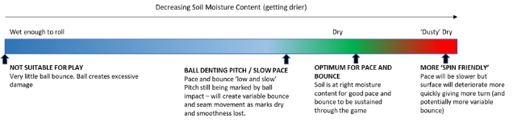

FIGURE 1. Relationship between pitch performance and moisture content from [7].

C. INTERNET OF THINGS (IoT)
The acronym “IoT” describes a system of linked devices that gathers and saves sensor data to improve the environment, remote regulation, and commerce [15]. IoT applications may have different types of sensors depending on their purpose.

Multiple IoT-based devices efficiently connect with things, procedures, or individuals, assisting the global connectivity network in bringing significant improvements in global cognition and lifestyle variables based on requirements [16]. IoT has significantly transformed human life, particularly in smart health, where sensors worn by patients provide information regarding health conditions, wrong habits and send alert messages in case of any abnormal health condition [17]. Forecasting meteorological events, including rain, drought, and snowfall with the help of sensors, farmers can take appropriate action to avoid crop damage.

D. SENSORS
Sensors transform physical properties like temperature or speed into observable electrical impulses from selected surroundings by detecting changes in the environment [18]. Different types of sensors include proximity sensors, position sensors, motion sensors, temperature sensors, pressure sensors etc [17]. Sensors are classified as Active and Passive. Passive sensors do not require external power supply to provide response signals, whereas Active sensors require excitation or power signals [18]. Active sensors include GPS and radar, while passive sensors can detect metal, electric field and heat.

Sensors interconnect different machines, several devices, and systems to monitor equipment in industries [18]. The portability and compact nature of the sensors enabled them to be attached to devices that are hard to access, which made the devices sophisticated. Sensors can intelligently detect harmful gas, radiation, and leakages in factories, mines, and industries by attaching them to walls or containers. Sensors are utilised in agriculture for soil moisture detection, climate monitoring, and automatic watering of crops based on air humidity and temperature, ensuring efficient crop management [17].

E. MACHINE LEARNING

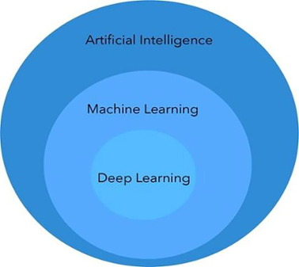
FIGURE 2. Relationship between Deep Learning, Machine Learning and Artificial Intelligence from [13].

The study of AI involves the application of computer systems to carry out activities such as speech recognition and language translation [19]. DL and ML are frequently used techniques in AI. ML makes predictions by identifying patterns and trends in data by using learning techniques from test data, examples, or big datasets [20]. Additionally, concept of statistics plays a crucial role in modern ML [21]. To evaluate and compare different ML models, metrics such as Mean Squared Error and R2 value derived from statistics are utilised.

Machine learning algorithms are classified as 1. Supervised, 2. Unsupervised, 3. Semi-supervised and 4. Reinforcement [22]. In this research work, supervised learning is used because the collected data has set of inputs and desired output variable. The output variable i.e., soil moisture level is continuous, so the supervised learning is called Regression [21].

The concept of ML is applied to improve the intelligence and capabilities of applications for various sectors including cybersecurity, agriculture, commerce and healthcare [23]. It is one of the key components of cybersecurity, which uses data analysis to determine trends, find malware, spot malicious activity, identify online dangerous areas, and safeguard cloud data [23]. It can be utilised in different stages of sustainable agriculture, including pre-production, production, processing, distribution, predicting crop yield, detecting diseases, managing livestock, and estimating demand. Machine-learning classifiers enable retailers to analyse extensive customer data for personalised services, while banks can enhance their frequency and effectiveness in interaction with customers [22].

F. DEEP LEARNING
Deep learning (DL) is a subcategory of ML that focuses on identifying multiple levels of distributed representations [24]. It uses multiple layers of processing to find patterns in large data and learns from concepts. It builds on its successive layers, with higher levels requiring more abstract concepts, without depending on prior data processing [25]. It is revolutionising various fields by solving complex problems in high-dimensional data, making it applicable in research field, industry, and administration [26].

G. IOT WITH MACHINE LEARNING
To increase the crop yield in agriculture fields, Bhanu et al. [4] proposed a system where email notifications are sent to the user providing information about the future tasks. It was performed by capturing the data (surrounding temperature, humidity, soil temperature, and soil moisture level) using sensors that are installed on the agriculture field and Naïve Nayes Algorithm was used for data analysis.

In another paper, Anand et al. [1] proposed a model for efficient crop prediction and growth using environmental parameters such as temperature, moisture, and rain sensor data. Here, Hybrid ML algorithm was used for analysis and the data was collected from Node MCU ESP8266 microcontroller and stored in Thingspeak Cloud Storage. A Smart Irrigation system was designed by Badotra et al. [27] to conserve water. Node MCU ESP8266 (Microcontroller) was used to collect the data about moisture content, temperature, and humidity. Based on transmitted data, if the moisture content decreases to certain level, the microcontroller will switch on the motor automatically using Relay Module.

G. NEURAL NETWORK
Most popularly used neural network layers are namely Fully Connected (Dense), Convolution, Deconvolution, and Recurrent. All types of neural networks can be used on image and multidimensional data [28]. To improve soil productivity, Patrizi et al. [29] proposed an approach that explains the usage of a DL approach to develop a virtual soil moisture sensor using Long Short-Term Memory (LSTM) network which is a recurrent neural network. The data included timestamp, temperature (soil and air), light radiation, and relative humidity of the air and soil (the target variable) with RMSE values of 0.15, 0.92, and 0.21 on three batches of data.

Cai et al. [30] designed a DL regression network with Adagrad optimisation function to save water and control drought. Fully connected layers were used for soil moisture prediction using time series and Taylor diagram to analyse the connection between atmospheric variables such as temperature, pressure, humidity, wind speed, precipitation, and soil moisture level. This system produced R² values of 0.97, 0.70, and 0.75 in three different regions.

Prakash et al. [31] proposed a Recurrent Neural Network to help the farmers for water management strategy. Three different datasets were used to train independently for soil moisture prediction, and data samples consist of soil temperature and moisture level. The system recorded R² values are 0.975, 0.939, and 0.786 [31]. Recurrent Neural Networks are not considered as part of this project because the collected data does not contain any sequential data like time series [28]. Convolution and Deconvolution layers are commonly used for image data. In this research, features of the dataset are numerical. So, Fully Connected (dense) layers are used as part of ML models because of their compatibility with the standard neural networks.

H. CRITICAL LITERATURE REVIEW (RELATED WORK)
Using environmental variables like temperature, humidity, soil moisture, pH and UV radiation, Patel et al. [32] created an IoT system with ML to recommend crops and fertilizers. The collected data was transferred to AWS S3 database and processed in NodeJS web application. XGBoost Algorithm was used to analyse the data, generating a suggestion template for farmers. The accuracy of this model was 99.318%. All the prediction models used in this research process produced accuracies 0.9, 0.99, 0.106, 0.952, 0.99 and 0.993. The author has not mentioned about the diversity of data. So, the models might have overfit which resulted in high accuracy values.

Another smart irrigation system was developed by Pratyush Reddy et al. [33], where temperature, humidity, and moisture sensors combined with ML was used to forecast crop water requirements. This system used Raspberry Pi microprocessor to host web server and store data. Decision tree algorithm was utilised for prediction. The results were sent via email alerts to the farmers, aiding informed water supply decisions. Some of the major limitations in this project are high implementation costs, regular maintenance and support for cloud storage.

Sanjeeva et al. [34] proposed an affordable model which uses sensors (e.g., infrared sensor, ultrasonic, pressure sensor, etc.) and microcontrollers (ESP-32 Dev Module) for monitoring and controlling the moisture content of soil in agricultural areas. This technology predicts future weather conditions using linear regression algorithm. Data was delivered in real time to Google Firebase, which stores and modifies data produced by different sensors and devices. This system improves farming practices by facilitating smarter farming techniques, enhancing agricultural practices, and increasing resource efficiency. Major drawbacks of this model are installation cost, maintenance, difficult to use and IoT system connected to firebase server is prone to virus attacks and system failures.

Singh et al. [35] presented an intelligent irrigation system using IoT, low-power LoRa (long range)-based wireless sensor networks, and ML. It predicts crop water requirements using environmental parameters such as air temperature, soil temperature, humidity, volumetric moisture content, and wind speed, with the linear discriminant analysis algorithm providing the highest efficiency of 91.25%. The main drawbacks of this system are the cost of installation and maintenance of soil sensor nodes and the usage of third-party cloud services, which are prone to cyberattacks.

The above related work provided basic understanding on all the aspects of the project such as atmospheric parameters, hardware designs ,data collection, analysis and integration of ML with IoT. The major limitations noticed were cost of installation and maintenance and usage third party cloud storage. This project finds a research gap to provide a solution in less budget without external cloud storage by embedding the ML into Microcontroller.

I. SENSOR DATA
An analysis was carried out on moisture data using SPSS (Statistical Package for Social Sciences). It reveals that, a non-stationary time series was influenced by meteorological parameters such as air/soil temperature, light, wind speed, and soil moisture [36]. The rate at which soil surface water evaporates is negatively correlated with air/soil temperature, light, and wind speed. The soil moisture parameter has a positive correlation with soil/air humidity, atmospheric pressure, and rainfall [36]. Temperature, Humidity and Pressure are the most frequent features used by the researchers who worked on soil moisture prediction [32][33][34][35].

Data accessibility and interpretability are two main reasons for the selection of temperature, humidity, and atmospheric pressure parameters. Data collection for these atmospheric parameters are relatively easy, and combining temperature, atmospheric pressure, and humidity can create a simple, interpretable model, aiding in understanding processes and explaining predictions to readers. Reasons to collect data instead of using online available datasets are:
1. Control over the quality of data,
2. Compatibility of data and units with the hardware setup and
3. Generate diverse data by simulating weather conditions.

III. PRACTICAL RESEARCH WORK (RESEARCH METHODOLOGY)
A.AIM
To develop a system to predict the soil moisture levels inside a cricket stadium by integrating IoT sensors with AI.

1. METHODOLOGY: Engineering/Build
2. APPROACH

Phase 1: Collecting the data from Arduino
Phase 2: Preprocess the data and apply ML models
Phase 3: Analyse the performance of the model
Phase 4: Convert the model into .h file and upload to Arduino

B. ARDUINO BLE 33 SENSE AND SENSOR DATA
Arduino BLE 33 Sense has been selected as the microcontroller for this research work. The main reasons to choose this Arduino board are its tiny form factor, its inbuilt environmental sensors to detect temperature, pressure, and humidity, and its capability to embed ML applications. It uses Arm® MbedTM OS and is based on the nRF52840 64MHz microcontroller, which runs at 3.3V [37]. It has 14 digital I/O pins, 8 analog input pins, an input voltage (nominal) of 5–18V, and a DC current per I/O of mA. It can be connected to a laptop using a micro-USB connector.
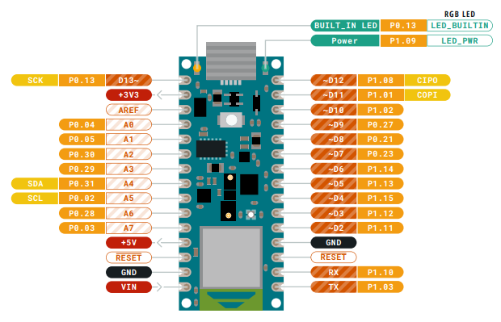
FIGURE 3. Pin diagram of Arduino BLE 33 Sense from [37].
FIGURE 4. HTS221 Sensor on Arduino BLE 33 Sense from [37].
FIGURE 5. LPS22HB Sensor on Arduino BLE 33 Sense from [37].
The HTS221 is a compact temperature and humidity sensor crucial for environmental monitoring in sensitive electronic equipment, converting physical temperature and moisture levels into digital data. It measures temperature in Celsius and humidity in percentage. The LPS22HB is a compact piezoresistive absolute pressure sensor. It operates within the temperature range of -40°C to +85°C and works as a digital output barometer. [37].

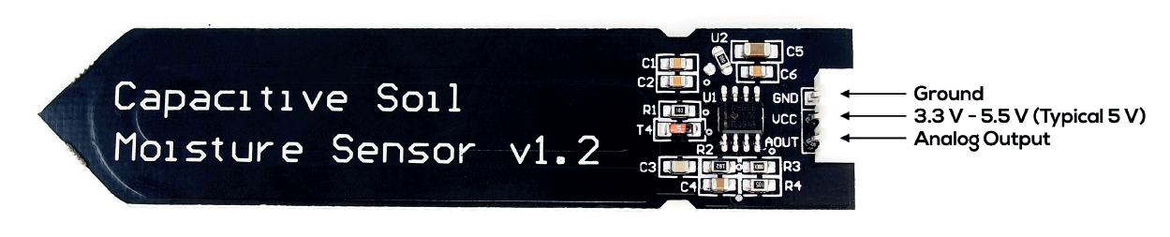
FIGURE 6. Capacitive Hygrometer Soil Humidity Moisture Sensor Module V1.2.

The Capacitive Hygrometer Soil Humidity Moisture Sensor Module V1.2 is an analog soil moisture sensor that uses capacitive sensing instead of resistive sensing. This device was selected because it has a long service life and resistance to corrosion. It can be placed into the soil to monitor moisture data. The Arduino Nano 33 BLE Sense microcontroller operates at 3.3V; the board may be affected by connecting signals with higher voltages (5V) [37]. The operating voltage of the moisture sensor is 5 volts. Therefore, two points labelled VUSB need to be soldered and supply power from the USB port.

C. ARDUINO WEB EDITOR
The Arduino web editor has been used to code and upload the sketches to the Arduino board. The reason to choose the Arduino web editor is that it is hosted online, offers the most recent features, and can be coded and uploaded to the cloud from any device. Output data is visible on the serial monitor and can be copied to the clipboard with one click and the data is saved as .xlsx file using Microsoft Excel.

D. ARDUINO LIBRARIES
HTS221 and LPS22HB are the two libraries used in collecting data from the Arduino. They help capture data from the temperature, humidity, and pressure sensors, respectively.

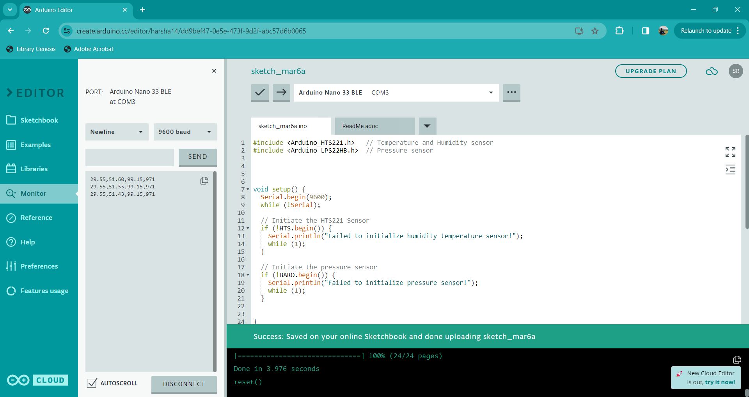
FIGURE 7. Arduino web editor with Serial monitor tab.

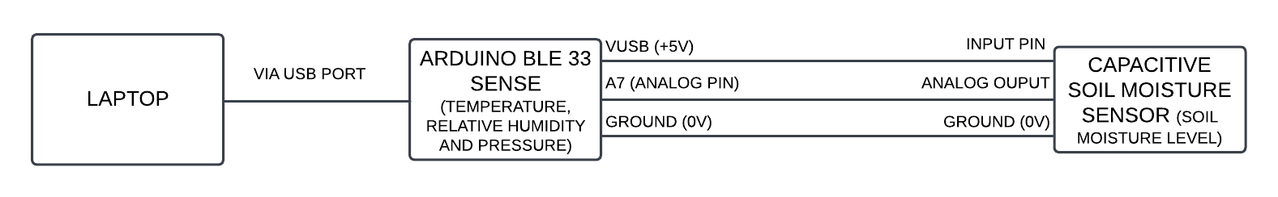FIGURE 8. Overview of Hardware Setup.

FIGURE 9. Code to collect temperature, pressure, humidity, and soil moisture level from Arduino.

E. DATASET
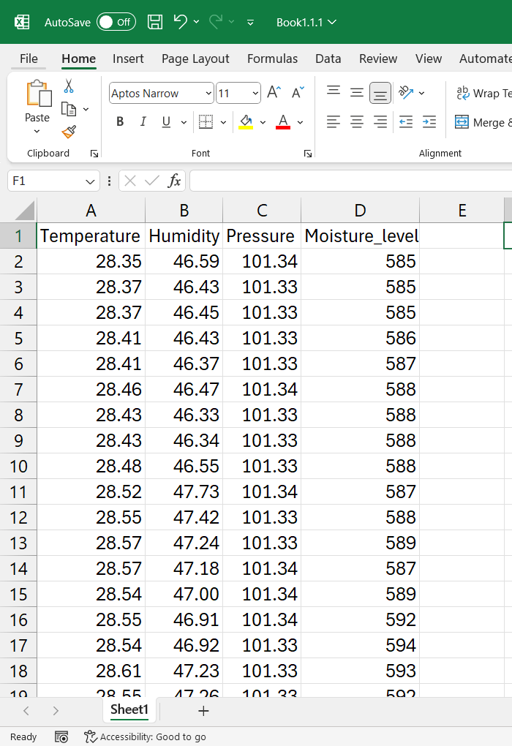
FIGURE 10. Data collected from Arduino Web Editor.

Entire Hardware setup is assembled as shown in Figure 8 with Arduino, Soil moisture sensor and Laptop. The code in Figure 9 is uploaded into the Arduino board using Arduino web editor. The sensor readings from Arduino are displayed on serial monitor as shown in Figure 7. The data collected from the serial monitor of the Arduino web editor is saved as an Excel file shown in Figure 10. This excel file was uploaded to the coding platform and used Python to preprocess and analyse the dataset.
Temperature in Celsius
Humidity in Percentage
Pressure in mm of Hg
Moisture level reading : Relative Units
Water - 577 and Dry Air - 1023

F. PYTHON
In this research project, Python is used for data analysis because, in the last ten years, the Python language has had a phenomenal surge in popularity in the computational science industry. It is the most preferred programming language because of the accessibility of tools and modules [38].

G. GOOGLE COLAB NOTEBOOK
Google Colab Notebook is used to execute Python programming because it can be accessed from any device using a Google account. It is a hosted Jupyter Notebook service that is great platform for ML as it gives users full access to hardware such as GPUs and TPUs [39].
H. PYTHON LIBRARIES

1. PANDAS
In this project, this versatile tool is used for data analysis and preprocessing, often paired with numerical computing, analytical libraries, and data visualisation libraries. It is an open-source Python module that offers high-performance data processing capabilities, combining NumPy, SciPy, and Matplotlib, derived from Python and data analysis and panel data [40]. Pandas is a popular data science and analytics Python library that makes it possible to work quickly and efficiently with spreadsheet-like data for importing, modifying, aligning, and merging.

2. NUMPY
In this project, Numpy is used to find square root of Mean Squared error value. It is an open-source Python library for mathematical and data science programming. It simplifies complex tasks for researchers, offering flexibility of python and speed comparable to optimised C code. NumPy works with N-dimensional arrays, linear algebra, random numbers, and Fourier transforms [41].

3. MATPLOTLIB
Matplotlib package is used to plot scatterplot of target feature, bar charts of features, loss values of the model training and performance of the model on training and testing datasets. It is a python data visualisation package which produces customisable 2D and 3D plots. It offers various visualisation options such as bar charts, scatter plots, and heatmaps. It can integrate with NumPy, Pandas and SciPy which enables researchers to create interactive visuals that effectively communicate complex data, enabling real-time manipulation [42].

4. SEABORN
Seaborn computes statistical transformations, provides a declarative API for converting data into images, maps data values to visual features, and shows descriptive axis labels. It is a Python library that integrates with Pandas and Matplotlib data structures to provide statistical visuals and fast data exploration and visualisation prototyping interface to Matplotlib, ensuring flexibility and stability for graphics. It is suitable for a wide range of tabular data[43]. Relationship between all the features is represented using this library.

5. TENSORFLOW
TensorFlow facilitates the development of DL and predictive analytics models by enabling experts to conduct more advanced and extensive training on their data [44]. It is an open-source framework for scientific and numerical computing of data. It refers to neural network operations on multidimensional data arrays, involving mathematical operations and tensor communication between edges and nodes, ensuring data and control flow.

6. KERAS
Keras is used for building neural networks and it is a powerful tool that allows users to create models like those in pure TensorFlow. It can be integrated with TensorFlow and it is an excellent choice for DL researchers [45].

I. CODE IMPLEMENTATION
1.DATA PREPROCESSING
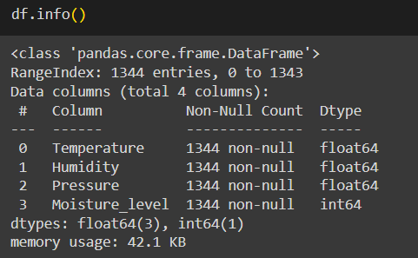
FIGURE 11. Overview of Variables used for Data Analysis.

All the independent variables used in this research work are float, and the target feature is an integer. The number of readings collected is 1344.

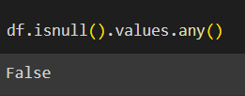
FIGURE 12. Information about Null values in the Dataset.

The above figure shows that the dataset has no null or missing values. Therefore, the dataset is pure. Splitting the entire dataset in an 80:20 ratio for training and testing. x is assigned to the independent features and y to the target feature.

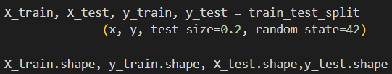
FIGURE 13. Information about Shape of train and test data.

Standard Scaler package is used to transform X_train and X_test data into values with zero mean and unit variance. This transformed data makes it easier for ML models to learn from the data.

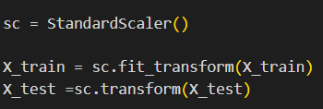
FIGURE 14. Information about Standard Scaler.

2. Keras Sequential model
The Keras sequential model is a linear stack of layers that are connected next to each other, so that the output of the first layer is the input for the next layer. This is compatible with a plain stack of layers with one input and one output [46].
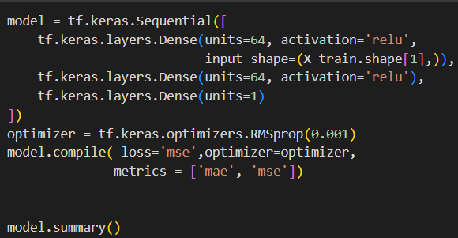
FIGURE 15. Keras Sequential Model code.

This model has three dense layers. The first two dense layers have 64 units and are activated by relu which is a popular choice for sequential models. It learns from complex data,. The last layer has one unit because the target feature is a single continuous value and has no activation function for linear activation. Mean Absolute Error and Mean Squared Error are used as performance metrics for the regression. Learning rate has been set to 0.001.

3. LEARNING CURVES
Learning curves are used to understand the fit of the model with the training data and illustrate how a certain learning measure has changed throughout the training of the ML model [47]. Training loss and validation loss are used as learning measure to indicate the ability of the model to fit training and validation data. There are two types of learning curves, namely 1. Optimisation learning curves (Mean Absolute Error or Mean Squared Error) and 2. Performance Learning curves (Accuracy or Precision) based on metrics used to calculate the performance of the model. High Bias/Underfitting and High Variance/Overfitting are two major issues that can be determined using learning curves.

High Bias: The model is unable to incorporate the complexity of the dataset [47].

Underfitting: The model fails to learn from training data, resulting in high error values.

High Variance: The model becomes too complex and fails to capture simple data trends.

Overfitting: The model works well with training data and fails on new data.
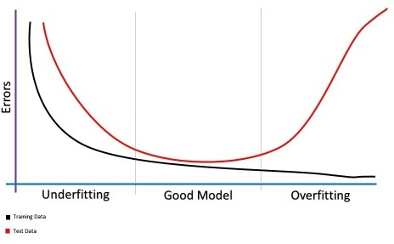
FIGURE 16. Learning Curves graph from [47].
Both the losses decrease to a certain point, and the validation loss starts increasing from a point indicating overfitting [47]. To avoid overfitting, training process needs to stop before the increase of validation loss.

J. PERFORMANCE METRICS
The target variable in this data analysis is continuous. So, the parameters used to access the prediction capability of ML algorithms involve measuring the error between the original and predicted values.

1. MEAN ABSOLUTE ERROR
It measures the total mean of deviation between original and predicted value. If the value of MAE is zero, then the model is the perfect fit for the dataset.

$MAE= \frac{1}{n}\sum_{i=1}^{n}{\left|Y_{i}-\hat{Y_{i}}\right|}$ (1)

EQUATION 1. MAE Formula from [48].
Where n – no of data samples,
$Y_{i}$and $\hat{Y_{i}}$are original and predicted values

2. MEAN SQUARED ERROR
It measures the total mean of squared deviation between original and predicted value. If the value of MSE is zero, then the model is perfect fit for the dataset.

$MSE=\frac{1}{n}\sum_{i=1}^{n}{{\left(Y_{i}-\hat{Y_{i}}\right)}^{2}}$(2)
EQUATION 2. MSE Formula from [48].

3. ROOT MEAN SQUARED ERROR

$RMSE= \sqrt{MSE}$ (3)
EQUATION 3. RMSE Formula from [48].

4.R-SQUARED
It indicates the degree of closeness of data with the regression line. A shown in Eq (1), if the value of R-Squared is one, then the model is perfect fit for the dataset.

$R^{2}=1-\frac{\sum_{i=1}^{m}{{{(X}_{i}-Y_{i})}^{2}}}{\sum_{i=1}^{m}{{\overline{(Y}-Y_{i})}^{2}}}$ (4)
EQUATION 4. R-Squared Formula from [49].

$\hat{Y}= \frac{1}{m}\sum_{i=1}^{m}{Y_{i}}$ (5)
EQUATION 5. Mean of true values from [49].

$Y_{i}$ and $X_{i}$ are original and predicted values

K. VISUAL STUDIO CODE
A Programming editor software named Visual Studio Code is used for code development and debugging [50]. The main reasons to use Visual Studio code are that it supports a fast code-build-debug cycle and extensions such as PlatformIO.

L. PLATFORMIO
In this research project, PlatformIO is used to embed the ML model into Arduino. It is an extension that was developed entirely in Python and doesn't rely on any other operating system libraries or tools [51]. It enables you to use computers with microcontrollers like Arduino.

M. ELOQUENT TINYML
Eloquent TinyML provides an eloquent interface for loading and running the models. It is an Arduino library used to deploy the TensorFlow Lite model onto an Arduino board [52]. The best performing model is converted into TensorFlow lite format and saved as model.tflite. Then the model.tflite is converted into model.h file.

1.PYTHON CODE
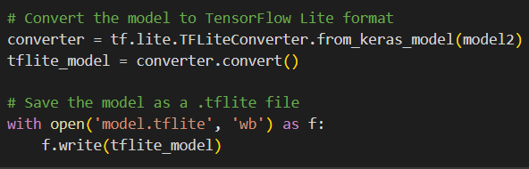
FIGURE 17. TensorFlow Lite format conversion code.

The best performing ML model is converted into model.tflite file as shown in Figure 17. Model.tflite model is later converted into header file (model.h) show in Figure 18 and uploaded into VS Code platform shown in Figure 21. Conversion of the ML model into header file makes it compatible for embedding into the Arduino.

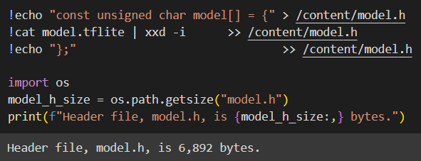
FIGURE 18. model.tflite to model.h conversion code.
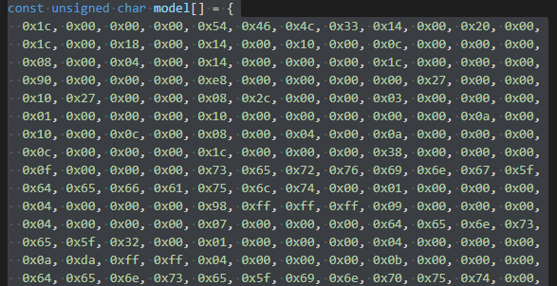
FIGURE 19. model.h file.

2. VISUAL STUDIO CODE
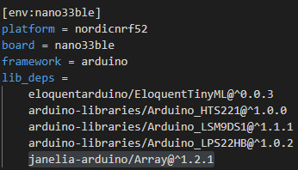
FIGURE 20. PlatformIO Project Configuration.

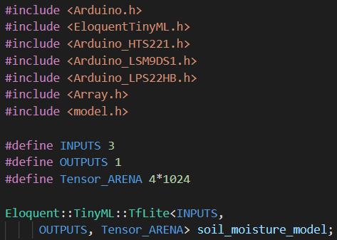
FIGURE 21. List of Libraries used in the Project.

The libraries included in the above figure are used to collect data from Arduino and input the data to the TensorFlow lite model. Temperature, pressure and humidity are the three defined input and soil moisture level is the defined output. Tensor_ARENA is defined as 4*1024 because there are four variables (input+output), and each variable is allocated with memory of 1024 bytes. Eloquent::TinyML::TfLite declares the entire model with configuration.

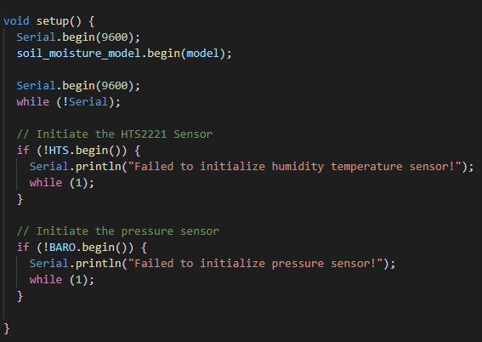
FIGURE 22. Loading the model into the System and initialising the Sensors.
soil_moisture_model.begin(model) – the model.h file loaded into the defined system. It prints an error message if the system fails to initialise the sensors inside the Arduino board.
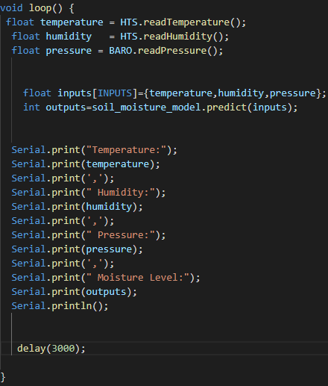
FIGURE 23. Declaring and printing the individual Input and Output Variables.

int outputs=soil_moisture_model.predict(inputs) – takes the input values from the Arduino and predicts the output using the model which was included in the soil_moisture_model. In the serial monitor, the system prints the values of temperature, humidity, pressure and predicted moisture level.

N. ETHICAL, LEGAL, SOCIAL, SECURITY AND PROFESSIONAL ISSUES
1. ETHICAL
This research work involves collection of original data about moisture levels inside a stadium. But in real time, it will be a challenging task to get permissions from ground staff to conduct research on play area. For this purpose, a sample dataset will be collected from an isolated place by simulating weather conditions for analysis. Data privacy is maintained, and the collected data does not include any information related to the public or animals.

2. LEGAL
The dataset used in this research project does not belong to any company and does not include any personal information. The collected data is securely stored in the Microsoft OneDrive folder. No sensitive information is used in data analysis. No patented technology is used, and the low-cost sensors used might produce inaccurate outcomes. Open sources and public resources are availed for coding and conducting work.

3.SOCIAL
This project needs soil and water for observing soil moisture and temperature levels, but it will not have any negative impact on the Ecosystem. The dataset analysed in this research project is collected in an isolated place without harming the environment or humans.

4.SECURITY
Sensors should be protected from tampering by regular inspections. During the research process, no security vulnerabilities have been detected. The dataset used in the research is securely protected in the Microsoft OneDrive folder and will be deleted six months later.

5.PROFESSIONAL
The prototype was designed with a low budget so that it could be affordable for every playground. This smart implementation on the grounds might result in a change in the work duties of groundstaff employees. This project is developed in such a way that it does not require any deep technical knowledge to understand the predicted output.

IV. RESULTS AND ANALYSIS
A. DATA EXPLORATION
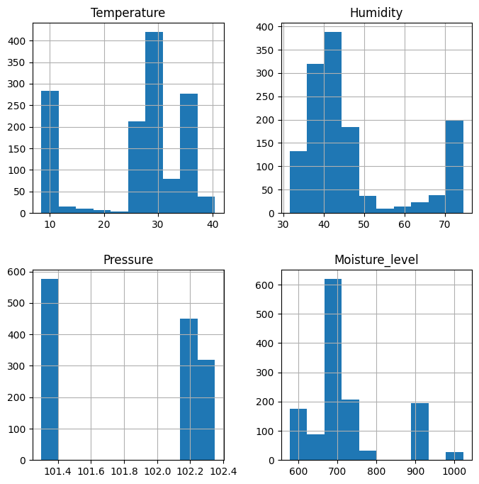
FIGURE 24. Bar Graph of Variables.
The above bar graph of all the independent features gives the overview of visual representation of data to understand the range and frequencies of collected readings.

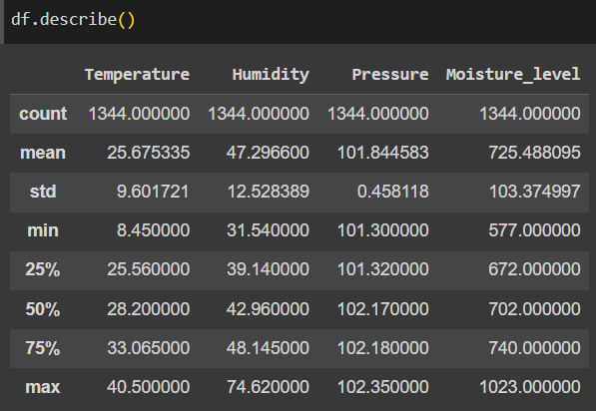
FIGURE 25. Statistical Summary of Variables.

The above figure provides the information regarding the statistical summary of the features which includes total count of the readings (count), mean, standard deviation (std), minimum value (min), percentage of values (25%, 50%, 75%) and maximum (max).

B. RESULTS OF SEQUENTIAL MODEL
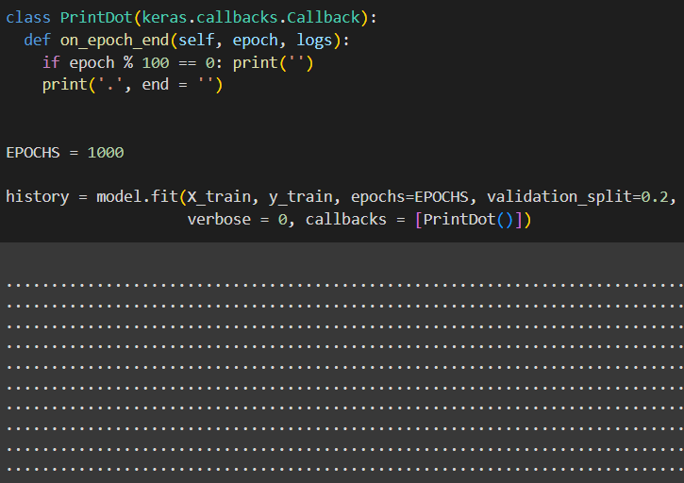
FIGURE 26. Training of Model.

Sequential model is trained with 80% of collected data (X_train, y_train) and 20% of training data is used for validation. Epoch value has been set to 1000 and PrintDot function is used to print dots instead of printing training loss and validation loss for each epoch. Loss value is Mean Squared Error.

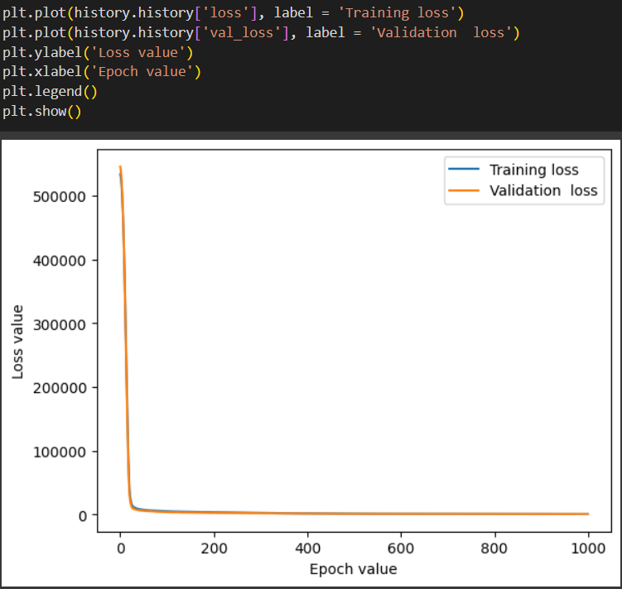
FIGURE 27. Learning curves of the Sequential model.

From the above graph both the learning curves are overlapping with each other which shows that the model is neither overfitting nor underfitting.

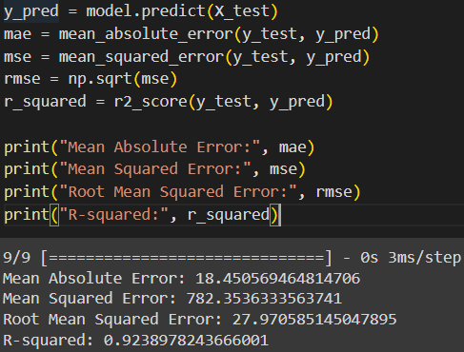
FIGURE 28. Performance metrics of the Sequential model.

From the learning curves and performance metrics of the sequential model, the model is good fit for the collected data because both the curves overlap. To further improve the performance of the model, the sequential model can be defined with 128 units in the first dense layer.

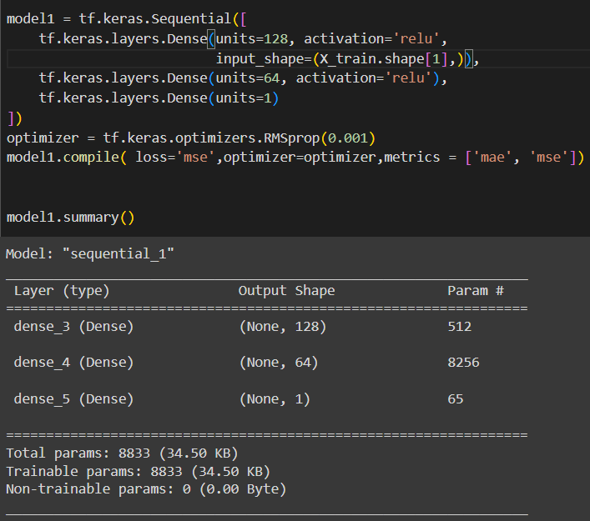
FIGURE 29. Sequential model with 128 units in the first dense layer.

FIGURE 30. Results of the Modified Sequential model.

From the above results, the modified Sequential model is also a good fit for the collected data without any issues. But compared to the original model, the values of performance metrics went down, so adding 128 units to the first dense layer does not improve the performance of the model. The next step would be adding an extra dense layer.

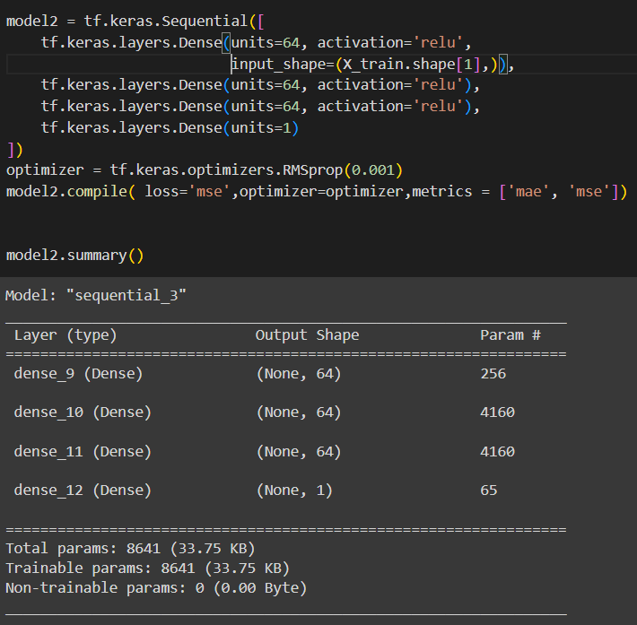
FIGURE 31. Sequential model with Extra dense layer

.

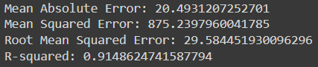
FIGURE 32. Results of the Modified Sequential model.

The below results show that the performance metrics were a little lower than the original model, and the learning curves show no defective behaviour. In the next steps, the units of the first dense layer of the sequential model are modified to 128, 256, and 512 units

TABLE 1
COMPARISON OF PERFORMANCE METRICS
Model | Mean Absolute Error | Mean Squared Error | Root Mean Squared Error | R-Squared
1. Sequential model | 18.45 | 782.35 | 27.97 | 0.92
2. Sequential model with 128 units in the first dense layer | 20.41 | 855.52 | 29.25 | 0.91
3. Sequential model with extra dense layer | 20.49 | 875.23 | 29.58 | 0.91
4. Sequential model with extra dense layer and 128 units in the first dense layer | 12.86 | 448.27 | 21.17 | 0.95
5. Sequential model with extra dense layer and 256 units in the first dense layer | 12.61 | 366.7 | 19.14 | 0.96
6. Sequential model with extra dense layer and 512 units in the first dense layer | 14.45 | 437.77 | 20.92 | 0.95

From the above performance metrics of three different modified models, the sequential model with an extra dense layer and 256 units in the first dense layer has shown the best performance across all metrics among all the models used. This model is converted into a model.tflite file using the TFLiteConverter function as shown in Figure 17, and it is further converted into a model.h file as shown in Figure 18 and downloaded for the next stage of the project.

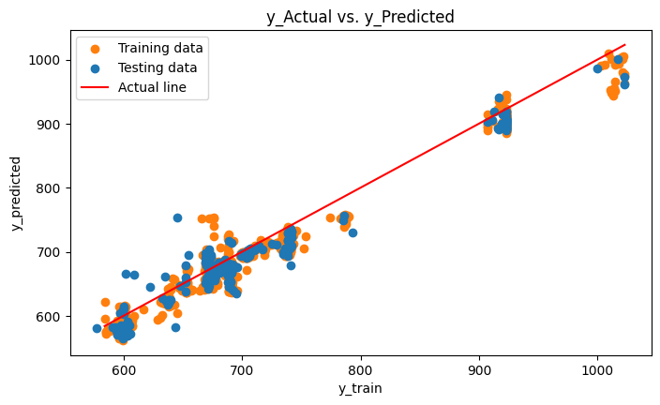
FIGURE 33. y_actual vs y_predicted graph

A scatterplot is used to visualise the y_actual and y_predicted for both training and testing data of Sequential model with extra dense layer and 256 units in the first dense layer. The actual line is y = x, the deviation of training and testing data points are very minimal from the actual line. Most of the data points are concentrated within the range of 600-700. All the actual and predicted values are closely aligned which describes the best performance and reliability of the model.

C. RESULTS OF VISUAL STUDIO CODE
The model.h generated from the ML model is added to Visual Studio Code as part of the application library resources, and the code required to run the Arduino is written in the main.cpp file. Using the PlatformIO extension, all the required libraries (Arduino libraries and Eloquent TinyML) are added, and the code is uploaded to the Arduino as shown in Figure 34. The code is uploaded to the Arduino which fetches the sensor values and predicts the soil moisture values. It uses ML model that is uploaded as model.h file. The values of all the input and output features will be displayed on the serial monitor.

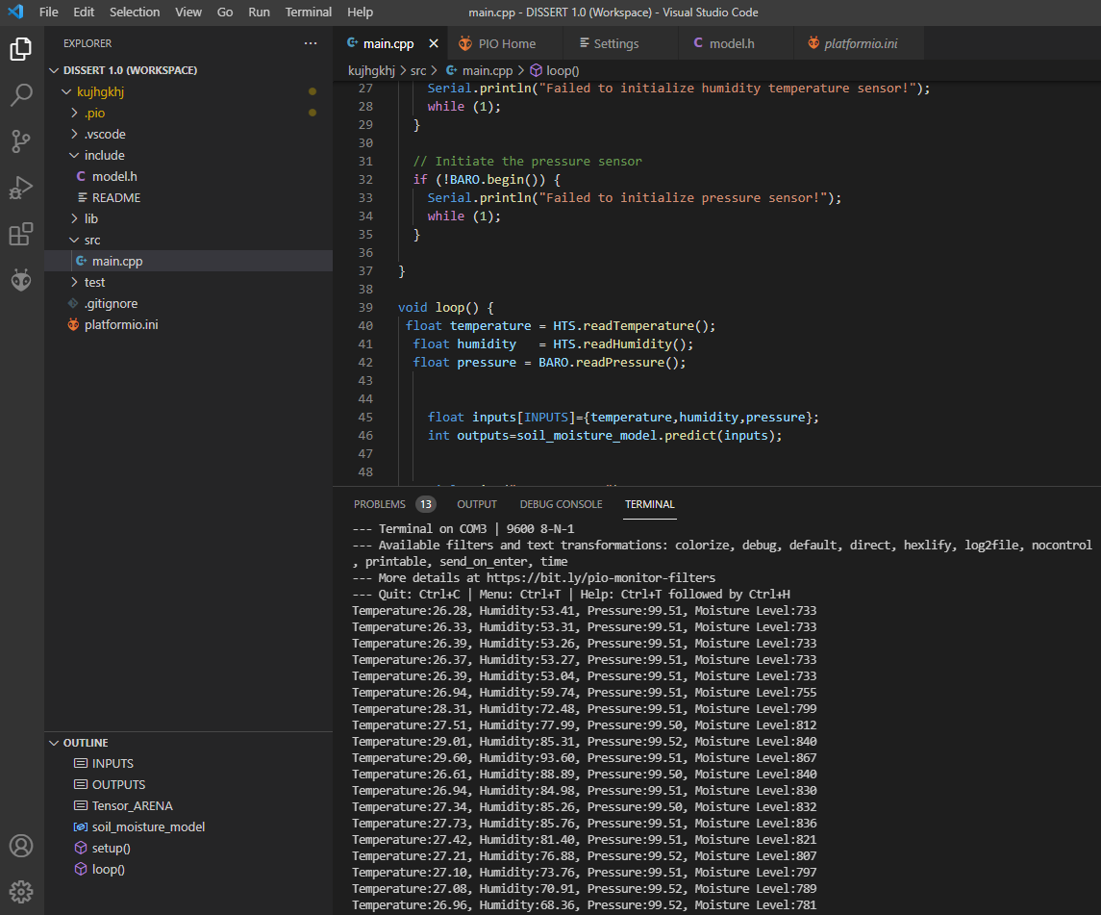
FIGURE 34. Visual Studio Code

V. CRITICAL EVALUATION, CONCLUSION AND RECOMMENDATIONS
A. CRITICAL EVALUATION
This research work is evaluated based on the progress made towards the objectives mentioned in the plan. It aims to integrate IoT sensors with AI to predict the moisture levels of the soil in stadiums. It started with the study of research papers on IoT sensors, ML models, and the integration of IoT sensors with AI or ML applications. Various types of hardware and ML models are reviewed. Although, there are not many past research papers working on the soil moisture of stadiums, but the papers related to agriculture with IoT helped in reviewing the applications based on soil moisture levels.

After examining the configurations of various microcontrollers, Arduino BLE 33 Sense microcontroller (Figure 3) is finalised because it supports embedding of ML models and has a tiny form factor. Atmospheric parameters are selected based on their explainability, interpretability, and their correlation with soil moisture. It needs deep understanding and practical experience to perform implementation and deploy it in stadiums or real time. So, a mock environment is created to understand the behaviour, simulate weather conditions, data collection and further analysis shown in Figure 7.

Model selection is one of the important stage in this research. Selecting the best performing model consumed time for trying out different possibilities by changing the units and dense layers of the sequential model from Table 1. Although it is a time-taking process, observed great impact for the research. The consistency of the outcomes was verified by running the code multiple times. In most cases, the metric scores were varied by less than 5%. Setting up the Visual Studio code platform has taken much effort to find the extension which supports embedding feature, configure the libraries, embed the ML model, input the data from Arduino, and print the predicted moisture level on the serial monitor is shown in Figure 34.

All the objectives and expected outcomes are achieved, and the results are documented within the allocated time. Regarding ethical, legal, social, security, and professional issues, the data required for this research is neither publicly available nor belongs to any company. It was generated using microcontroller in an isolated place by simulating different weather conditions without harming the atmosphere or human society. It is securely saved in a Microsoft OneDrive folder and will be deleted six months later. This project is modelled in such a way that it would be easily explained to the ground staff, who do not have any technical knowledge.

The limitations of this project include sensor quality. Because of their small size, they might produce inaccurate results due to heat dissipation from the microcontroller during long-term usage. Addition of timestamp feature to the dataset would have helped the model to understand the dynamic nature of soil moisture level and time dependent constraints. Model used in this analysis cannot consider the unforeseen events such as irregular irrigation, sudden changes in the weather and natural calamities.

B. CHALLENGES
Few challenges were faced while performing research. During the first stage of exploration in terms of research papers, there are only few papers that discussed about soil moisture conditions at stadium levels. It became bit challenging to gather information and dataset that are required to support this project. However, reviewing literature related to agriculture field paved a path in grabbing some knowledge and foundation for building a dataset, to carry out effective research.

Another challenging step was setting up the Hardware resource connectivity. Although each sensor was initially tested individually and then combined with the microcontroller, it ended producing inaccurate results. Arduino BLE 33 Sense can only support output of 3V, but the soil moisture needed a 5V input supply. There is a pin on the Arduino that is marked Vusb, and it has two points that need to be soldered to get 5V output. When the soil moisture was connected to the Arduino with an input of 3V, it produced inaccurate results. Once the soldering is done and given 5V input, soil moisture sensor produced accurate readings. While collecting diverse data for analysis, simulating different weather conditions was possible with room heater, but atmospheric pressure could not be simulated. The developed system would be more complete if the values of features could be simulated.

While coding, it was tough to identify the platform to combine and integrate ML model with Arduino in terms of compatibility. Arduino editor was used initially to combine ML model with Arduino. But the platform did not provide many options to identify the errors for in-between changes. Found the best possible way to embed the model into the Arduino and configuring the setup in Visual Studio Code using PlatformIO, this objective has consumed more time than the time allotted in the project plan.

C. CONCLUSION
This study aimed to develop a system for predicting soil moisture levels by integrating IoT and AI to maintain and monitor the moisture level across grounds. This research used an Arduino BLE 33 Sense along with a soil moisture sensor as a hardware prototype. The TensorFlow library was used to build ML models, the PlatformIO extension in Visual Studio Code and Eloquent TinyML is used to embed the ML model into Arduino.

The research question mainly asked how accurately soil moisture can be monitored, what factors need to be considered to collect data, and how to simulate weather conditions. The finalised ML model produced an R-squared value of 0.96. Temperature, pressure, and humidity were the features finalised to predict soil moisture because of their explainability and correlation with soil moisture levels. Values of temperature and humidity were simulated using a room heater, but they cannot simulate the values of atmospheric pressure. The range of soil moisture values recorded for this research is 577(wet) - 1023(dry). In the ideal scenario, the value of soil moisture is expected to be around 700-750 for optimum soil conditions.

Data was collected from hardware prototype in an isolated environment. In case of stadium, the play area can be divided into parts and each part can be accommodated with a dedicated soil moisture sensor. Data analysis can be done on moisture levels of all parts for better understanding of the ground. All the project's features were created with the intention of being simply described to any reader without technical knowledge. The origin point of this project was to create a hardware setup for monitoring soil moisture levels in real-time within a limited installation and maintenance budget. The result in the report showed that this system achieved the aim of the project. This system can also be used on play fields, such as golf courts and football grounds.

D. FUTURE RECOMMENDATIONS
Exploring many research papers have provided valuable insights while working on this project. Additionally, some future enhancements and suggestions were identified and discussed in this section for future scope. Adding date and time features to the dataset is one of the most important features that makes this project more reliable and advanced. These features will provide scope to use Time Series Analysis and forecast the future reading using DL techniques such as LSTM and ARIMA. The prototype used in this project has only one soil moisture sensor, assuming the entire play area maintains uniform moisture levels. Multiple soil moisture sensors can be deployed to collect data from multiple parts of the play area at the same time. This helps in increasing the effectiveness of the system by tackling the irregular distribution of soil moisture across the ground.

Pratyush Reddy et al. [20] created a smart irrigation system that predicts crop requirements and informs water supply decisions to farmers via email. The option to configure the requirements of turf grass and send notification alerts to take decisions in advance using mobile application makes the job easy for ground staff. Automating the irrigation system could be a great expansion to this research. Gnanavel et al. [53] implemented a prototype of automated irrigation system using Arduino uno, soil moisture sensor, water level sensor and pump motor. Whenever the moisture level goes lower than a predefined value, then the Arduino sends a signal to start the motor for water. Similarly, an automated irrigation system can be added to the current research by connecting the Arduino and motor to a web interface wirelessly. In this scenario, the ML can be embedded into the web application, the readings from the Arduino will be analysed on the web application and signal to turn on or turn off the motor will be sent based on predicted soil moisture level.
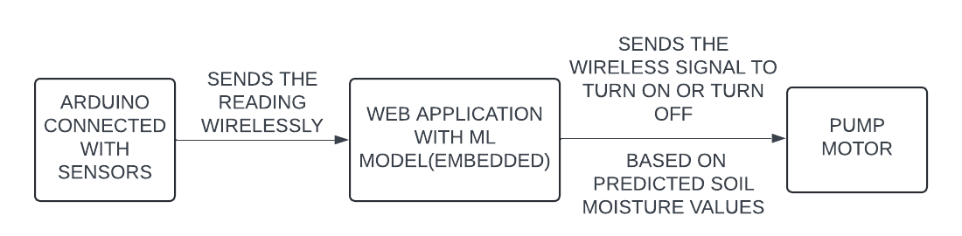
FIGURE 35. Overview of Wireless Irrigation Setup.

The live data from the Arduino and predicted soil moisture values can be saved on the cloud storage and used to create dashboards for useful insights. Visual Studio Code was used for printing the predicted soil moisture levels in this research. Instead, the predicted soil moisture values can be printed on an external display connected to the Arduino.

REFERENCES
- R. Anand, D. Sethi, K. Sharma, and P. Gambhir, “Soil moisture and atmosphere components detection system using IOT and machine learning,” 2019 International Conference on Smart Systems and Inventive Technology (ICSSIT), pp. 842–847, Nov. 2019. doi:10.1109/icssit46314.2019.8987754.
- P. K. Kashyap, S. Kumar, A. Jaiswal, M. Prasad, and A. H. Gandomi, “Towards precision agriculture: IOT-enabled intelligent irrigation systems using Deep Learning Neural Network,” IEEE Sensors Journal, vol. 21, no. 16, pp. 17479–17491, Aug. 2021. doi:10.1109/jsen.2021.3069266.
- S. Murlidharan, V. K. Shukla, and A. Chaubey, “Application of machine learning in Precision Agriculture using IOT,” 2021 2nd International Conference on Intelligent Engineering and Management (ICIEM), pp. 34–39, Apr. 2021. doi:10.1109/iciem51511.2021.9445312.
- K. N. Bhanu, H. J. Jasmine, and H. S. Mahadevaswamy, “Machine learning implementation in IOT based intelligent system for Agriculture,” 2020 International Conference for Emerging Technology (INCET), pp. 1–5, Jun. 2020. doi:10.1109/incet49848.2020.9153978.
- “HARARE WATER CRISIS: Indian cricket players told to take quick showers and cut pool sessions,” New Zimbabwe, Available: https://www.newzimbabwe.com/harare-water-crisis-indian-cricket-players-told-to-take-quick-showers-and-cut-pool-sessions/ (accessed Mar. 7, 2024).
- “What is the sub air system in a cricket stadium?,” Sports Adda, Available: https://www.sportsadda.com/cricket/features/sub-air-system-explained (accessed Mar. 7, 2024).
- Z. Kılıç, “The importance of water and conscious use of water,” International Journal of Hydrology, vol. 4, no. 5, pp. 239–241, Oct. 2020. doi:10.15406/ijh.2020.04.00250.
- M. E. Jensen and R. G. Allen, Evaporation, Evapotranspiration, and Irrigation Water Requirements. Reston, VA: American Society of Civil Engineers, 2016.
- H. McNairn, A. Merzouki, A. Pacheco, and J. Fitzmaurice, “Monitoring soil moisture to support risk reduction for the agriculture sector using RADARSAT-2,” IEEE Journal of Selected Topics in Applied Earth Observations and Remote Sensing, vol. 5, no. 3, pp. 824–834, Jun. 2012. doi:10.1109/jstars.2012.2192416.
- M. E. Brown et al., “NASA’s Soil Moisture Active Passive (SMAP) mission and opportunities for applications users,” Bulletin of the American Meteorological Society, vol. 94, no. 8, pp. 1125–1128, Aug. 2013. doi:10.1175/bams-d-11-00049.1.
- B. Majone et al., “Wireless sensor network deployment for monitoring soil moisture dynamics at the field scale,” Procedia Environmental Sciences, vol. 19, pp. 426–435, 2013. doi:10.1016/j.proenv.2013.06.049.
- M. Abdul Hadi, A. Khatoon, S. Ibrahim Patel, S. Rizwan, and M. Furkhan, “Drainage System of a Cricket Stadium,” International Journal of Innovative Research in Technology, vol. 9, no. 12, pp. 1268–1273, May 2023.
- “Controlling moisture,” Controlling Moisture | Grounds Management Toolkit, Available: https://resources.thegma.org.uk/your-sport/cricket/maintaining-your-cricket-ground/cricket-season/preparing-pitches-play/phase-2-3 (accessed Feb. 28, 2024).
- S. Amritha and V. Rani, “Characteristics Study of Site Soil for an Efficient Cricket Pitch ,” International Research Journal of Engineering and Technology (IRJET) , vol. 07, no. 02, pp. 1711–1714, Feb. 2020.
- M. S. Al-kahtani, F. Khan, and W. Taekeun, “Application of internet of things and sensors in Healthcare,” Sensors, vol. 22, no. 15, p. 5738, Jul. 2022. doi:10.3390/s22155738.
- P. Midhila et al., “Importance and applications of internet of things (IOT),” Internet of Things, pp. 1–16, Mar. 2023. doi:10.1201/9781003226888-1.
- D. Sehrawat and N. S. Gill, “Smart sensors: Analysis of different types of IOT sensors,” 2019 3rd International Conference on Trends in Electronics and Informatics (ICOEI), Apr. 2019. doi:10.1109/icoei.2019.8862778.
- M. Javaid, A. Haleem, S. Rab, R. Pratap Singh, and R. Suman, “Sensors for daily life: A Review,” Sensors International, vol. 2, p. 100121, 2021. doi:10.1016/j.sintl.2021.100121.
- H. Pallathadka et al., “Impact of machine learning on management, healthcare and Agriculture,” Materials Today: Proceedings, vol. 80, pp. 2803–2806, 2023. doi:10.1016/j.matpr.2021.07.042.
- F. Weber and R. Schütte, “A domain-oriented analysis of the impact of machine learning—the case of retailing,” Big Data and Cognitive Computing, vol. 3, no. 1, p. 11, Jan. 2019. doi:10.3390/bdcc3010011.
- Z. Ge, Z. Song, S. X. Ding, and B. Huang, “Data Mining and analytics in the process industry: The Role of Machine Learning,” IEEE Access, vol. 5, pp. 20590–20616, 2017. doi:10.1109/access.2017.2756872.
- I. Lee and Y. J. Shin, “Machine learning for enterprises: Applications, algorithm selection, and challenges,” Business Horizons, vol. 63, no. 2, pp. 157–170, Mar. 2020. doi:10.1016/j.bushor.2019.10.005.
- I. H. Sarker, “Machine learning: Algorithms, real-world applications and Research Directions,” SN Computer Science, vol. 2, no. 3, Mar. 2021. doi:10.1007/s42979-021-00592-x.
- Y. Guo et al., “Deep Learning for Visual Understanding: A Review,” Neurocomputing, vol. 187, pp. 27–48, Apr. 2016. doi:10.1016/j.neucom.2015.09.116.
- N. Rusk, “Deep learning,” Nature Methods, vol. 13, no. 1, pp. 35–35, Dec. 2015. doi:10.1038/nmeth.3707.
- Y. LeCun, Y. Bengio, and G. Hinton, “Deep learning,” Nature, vol. 521, no. 7553, pp. 436–444, May 2015. doi:10.1038/nature14539.
- S. Badotra et al., "Smart Irrigation System using Internet of Things (IoT) and Machine Learning," 2021 9th International Conference on Reliability, Infocom Technologies and Optimization (Trends and Future Directions) (ICRITO), Noida, India, 2021, pp. 1-4, doi: 10.1109/ICRITO51393.2021.9596139.
- M. Isaksson, “Four common types of neural network layers,” Medium, Available: https://towardsdatascience.com/four-common-types-of-neural-network-layers-c0d3bb2a966c (accessed Apr. 28, 2024).
- G. Patrizi et al., “A virtual soil moisture sensor for smart farming using Deep Learning,” IEEE Transactions on Instrumentation and Measurement, vol. 71, pp. 1–11, 2022. doi:10.1109/tim.2022.3196446.
- Y. Cai, W. Zheng, X. Zhang, L. Zhangzhong, and X. Xue, “Research on soil moisture prediction model based on Deep Learning,” PLOS ONE, vol. 14, no. 4, Apr. 2019. doi:10.1371/journal.pone.0214508.
- S. Prakash, A. Sharma and S. S. Sahu, "Soil Moisture Prediction Using Machine Learning," 2018 Second International Conference on Inventive Communication and Computational Technologies (ICICCT), Coimbatore, India, 2018, pp. 1-6, doi: 10.1109/ICICCT.2018.8473260.
- S. Patel, M. Jain, S. Pai, and S. Korde, “Smart Agriculture using IoT and Machine Learning,” International Research Journal of Engineering and Technology (IRJET), vol. 08, no. 04, pp. 4533–4536, Apr. 2021.
- K. S. Pratyush Reddy, Y. M. Roopa, K. Rajeev L.N. and N. S. Nandan, "IoT based Smart Agriculture using Machine Learning," 2020 Second International Conference on Inventive Research in Computing Applications (ICIRCA), Coimbatore, India, 2020, pp. 130-134, doi: 10.1109/ICIRCA48905.2020.9183373.
- P. Sanjeeva et al., “Soil moisture predictive analysis using IOT and machine learning,” E3S Web of Conferences, vol. 391, p. 01147, 2023. doi:10.1051/e3sconf/202339101147
- D. K. Singh et al., “IOT-driven model for weather and soil conditions based on precision irrigation using machine learning,” Security and Communication Networks, vol. 2022, pp. 1–10, May 2022. doi:10.1155/2022/7283975.
- Y. Cai, W. Zheng, X. Zhang, L. Zhangzhong, and X. Xue, “Research on soil moisture prediction model based on Deep Learning,” PLOS ONE, vol. 14, no. 4, Apr. 2019. doi:10.1371/journal.pone.0214508.
- “Nano 33 ble sense,” Arduino, Available: https://docs.arduino.cc/hardware/nano-33-ble-sense/ (accessed Mar. 13, 2024).
- S. Raschka, J. Patterson, and C. Nolet, “Machine learning in Python: Main developments and technology trends in Data Science, Machine Learning, and Artificial Intelligence,” Information, vol. 11, no. 4, p. 193, Apr. 2020. doi:10.3390/info11040193.
- “Colab.google,” Google Colaboratory, Available: https://colab.google/ (accessed Mar. 16, 2024).
- P. Gupta and A. Bagchi, “Introduction to pandas,” Essentials of Python for Artificial Intelligence and Machine Learning, pp. 161–196, 2024. doi:10.1007/978-3-031-43725-0_5.
- P. Gupta and A. Bagchi, “Introduction to numpy,” Essentials of Python for Artificial Intelligence and Machine Learning, pp. 127–159, 2024. doi:10.1007/978-3-031-43725-0_4.
- A. Lavanya et al., “Assessing the performance of Python Data Visualization Libraries: A Review,” International Journal of Computer Engineering in Research Trends, vol. 10, no. 1, pp. 28–39, Jan. 2023. doi:10.22362/ijcert/2023/v10/i01/v10i0104.
- M. Waskom, “Seaborn: Statistical data visualization,” Journal of Open Source Software, vol. 6, no. 60, p. 3021, Apr. 2021. doi:10.21105/joss.03021.
- G. Zaccone and Md. R. Karim, “A First Look at TensorFlow,” Deep Learning with TensorFlow, 2nd ed, Birmingham: Packt Publishing Ltd., 2018, pp. 31–55.
- D. Grattarola and C. Alippi, "Graph Neural Networks in TensorFlow and Keras with Spektral [Application Notes]," IEEE Computational Intelligence Magazine, vol. 16, no. 1, pp. 99-106, Feb. 2021, doi: 10.1109/MCI.2020.3039072.
- Keras team, “Keras Documentation: The sequential model,” Keras, Available: https://keras.io/guides/sequential_model/ (accessed Mar. 27, 2024).
- Baeldung, “What is a learning curve in machine learning?,” Baeldung on Computer Science, Available: https://www.baeldung.com/cs/learning-curve-ml (accessed Apr. 6, 2024).
- E. A. Hami and P. Pougnet, Embedded Mechatronic Systems 1. London, UK: ISTE Press, 2019.
- D. Chicco, M. J. Warrens, and G. Jurman, “The coefficient of determination R-squared is more informative than smape, Mae, MAPE, MSE and RMSE in regression analysis evaluation,” PeerJ Computer Science, vol. 7, Jul. 2021. doi:10.7717/peerj-cs.623.
- “Visual studio code frequently asked questions,” Visual studio code, Available: https://code.visualstudio.com/docs/supporting/FAQ#:~:text=Visual%20Studio%20Code%20is%20a,such%20as%20Visual%20Studio%20IDE. (accessed Mar. 26, 2024).
- “Your gateway to embedded software development excellence,” PlatformIO, Available: https://platformio.org/ (accessed Mar. 26, 2024).
- “EloquentTinyML by eloquentarduino,” Platformio registry, Available: https://registry.platformio.org/libraries/eloquentarduino/EloquentTinyML (accessed Mar. 26, 2024).
- S. Gnanavel, M. Sreekrishna, N. DuraiMurugan, M. Jaeyalakshmi and S. Loksharan, "The Smart IoT based Automated Irrigation System using Arduino UNO and Soil Moisture Sensor," 2022 4th International Conference on Smart Systems and Inventive Technology (ICSSIT), Tirunelveli, India, 2022, pp. 188-191, doi: 10.1109/ICSSIT53264.2022.9716368.

APPENDIX I

- dISSERTATION CODE AND IMAGES LINK - KF7029_Dissertation_W21027847

